BE SELF CARE AWARE
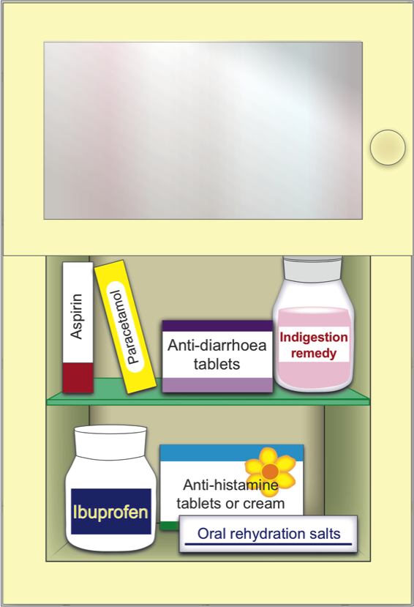
Speak to your local pharmacist about stocking up on your medicines cabinet to treat common conditions for you and your family
The following medications can be purchased from pharmacies or your local supermarket and are generally cheaper than buying them on prescription.
- Allergy medicines
- Simple pain killers like paracetamol and ibuprofen
- Sore throat, coughs, colds and flu medications
- Heartburn and indigestion remedies
- Pile (haemorrhoid) treatments
- Anti-diarrhoea medication
- Rehydration salts
- First aid kit including plasters and bandages
- Thermometer
- Tissues
By keeping a selection of essential medications at home you can treat common conditions in a timely manner, avoid unnecessary trips to see your doctor and/or even visits to the A&E department.
For more information on treating common conditions go to:
http://www.nhs.uk/Livewell/Pharmacy/Pages/Commonconditions.aspx
For more information on what to keep in your medicine cabinet go to:
http://www.nhs.uk/Livewell/Pharmacy/Pages/Yourmedicinecabinet.aspx

YOUR LOCAL PHARMACY
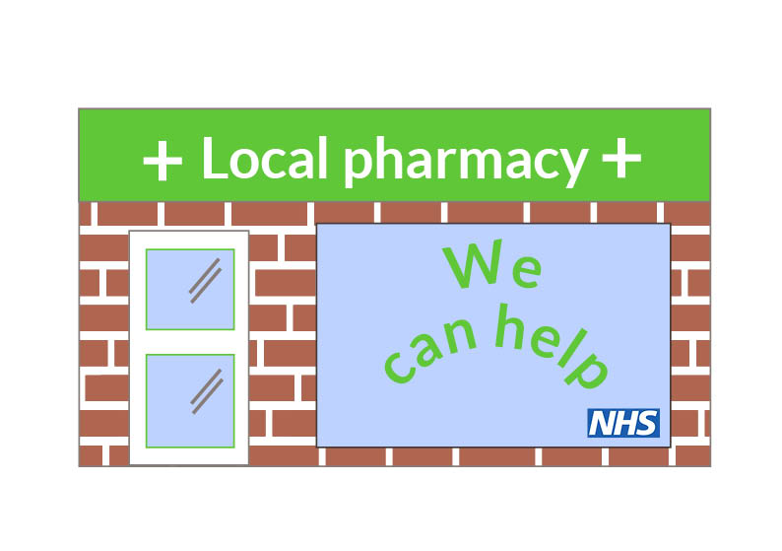
Community pharmacists have the knowledge and skills to help and advise you on treating common conditions, how to use the medicines you have at home and local services that are available to you.
There are a number of pharmacies across our area. They can be found in local communities, on the high street, in some supermarkets and in shopping centers.
You do not need to make an appointment to see the pharmacist, just pop in. They are always happy to help and answer any questions you have.
Many pharmacies are open late nights and at the weekend, which is convenient for people who work and if you or any member of your family feels unwell when the doctor’s surgery is closed.
Details of your local pharmacy and their opening times can be found here:
www.nhs.uk/chemist

